EXCAVATION AT GREENBANK HOUSE DONE
On Sunday, 27th of July, 2014, the Forum had a stall at Archaeology Day at Greenbank House and Gardens. The event was run by the National Trust for Scotland. Derek Alexander of NTS organised the dig. Four of our members and interested teenager, Conor Brett, were volunteers in a small excavation of three trenches in different parts of the gardens.
Trench 1 was the site of a saw mill and Trench 3 was an attempt to find building foundations.
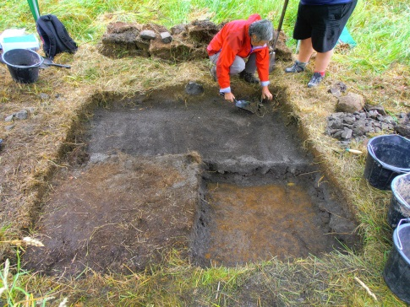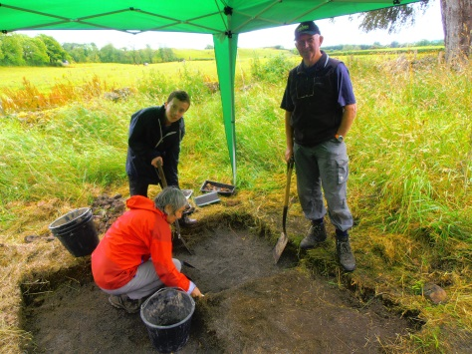
Maggie examining a five inch layer Maggie, Conor and Bill
of greyish ash at sawmill site Trench 1
Trench 1

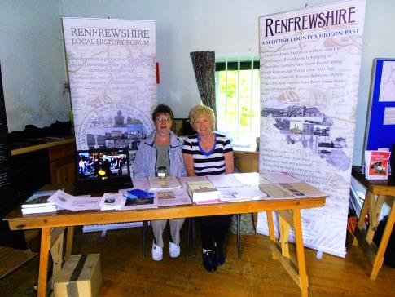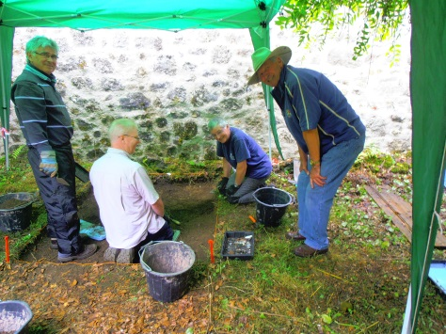
Janet and Maimie Ian with other volunteers
manning the Forum Stall Trench 3

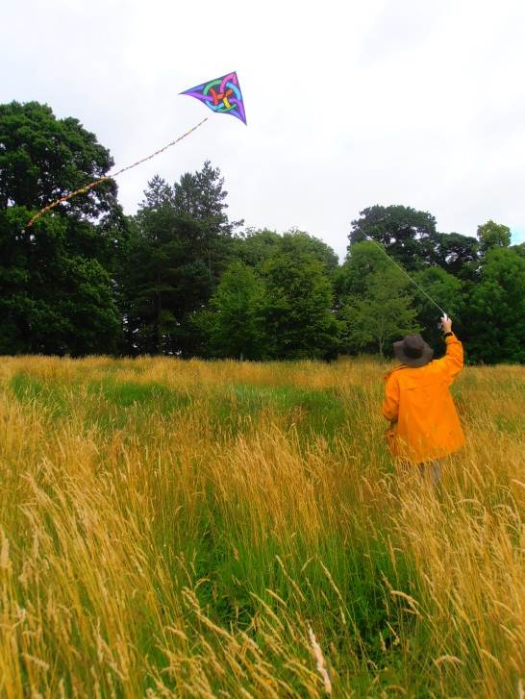
DIG IT! 2015 DONE?

Dig it! 2015 is a yearlong series of projects co-ordinated by the Society of Antiquaries of Scotland and Archaeology Scotland. Seven of our members manned a Forum stall at the launch of this project at Rouken Glen on Saturday, 15th March. The highlight of the day was meeting another stall holder, John Wells, from Rosie's Scottish National Aerial Photography Scheme (SNAPS). He generously gave the Forum a kite with a camera which will be extremely useful for aerial photography.

LOCHERFIELD BLEACHWORKS
In a spell of dry weather in the summer of 2014 the flow of the Locher Water (between Kilbarchan and Bridge of Weir) was reduced to a trickle. This revealed the footings of what appeared to have been an old weir or dam with the timbers preserved by decades of immersion in water. The weir or dam, constructed in the early 1860s, was associated with Locherfield Bleach Works which was owned by Hardie, Starke & Co. Forum members have been investigating the site and its history.
This field survey into the remains of the bleach works is continuing and a second weir has been revealed on the bank of the river further downstream where a large spill tunnel exits into the river.

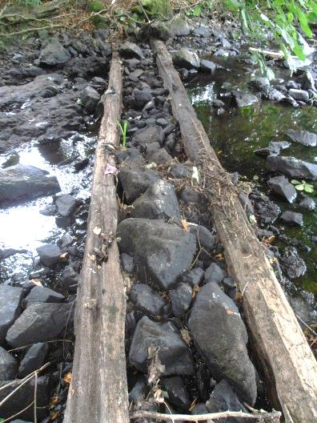
The Regional Framework for Local History and Archaeology was a partnership involving eight local authorities, led by Glasgow Museums. Forum members contributed essays to the project. Some essays written for this project, including Stuart Nisbet’s The Eighteenth Century, are now available to download via the Related Documents on the following link. Further essays will be added in due course. (Website may ask you to sign in, but close this page and website page appears,)
http://www.glasgowlife.org.uk/museums/abocut-glasgow-museums/publications/online-publications/Pages/Essays-on-the-Local-History-and-Archaeology-of-West-Central-Scotland.aspx

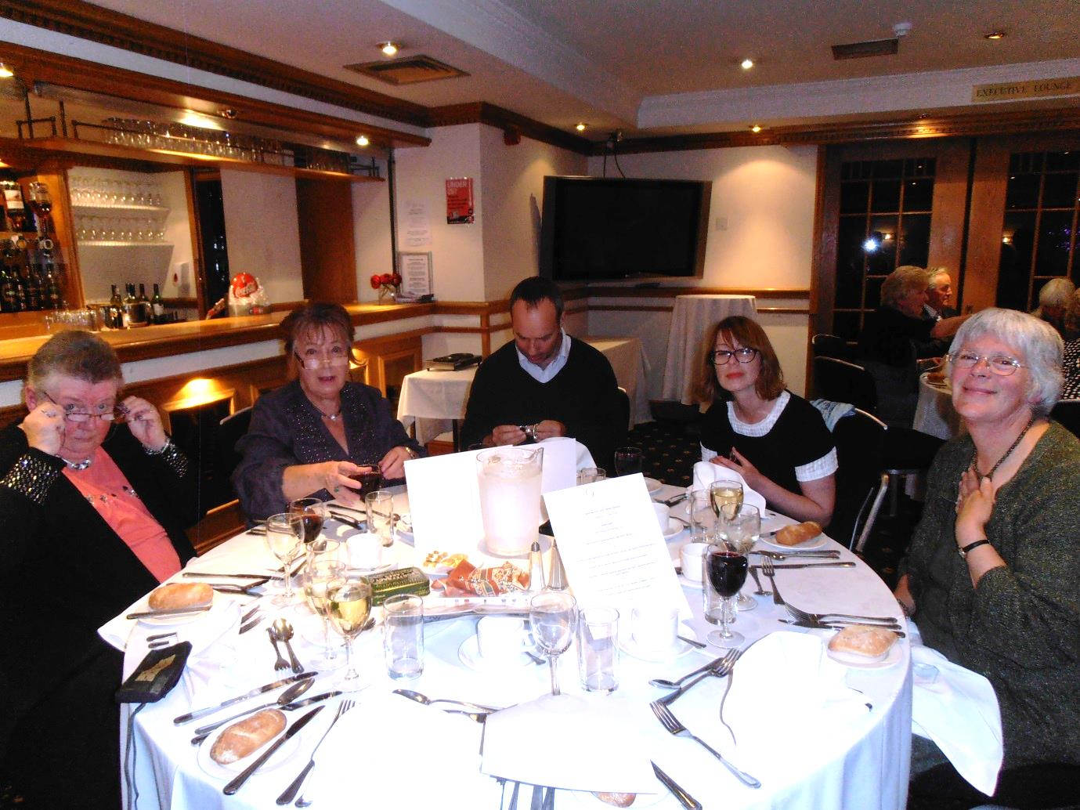
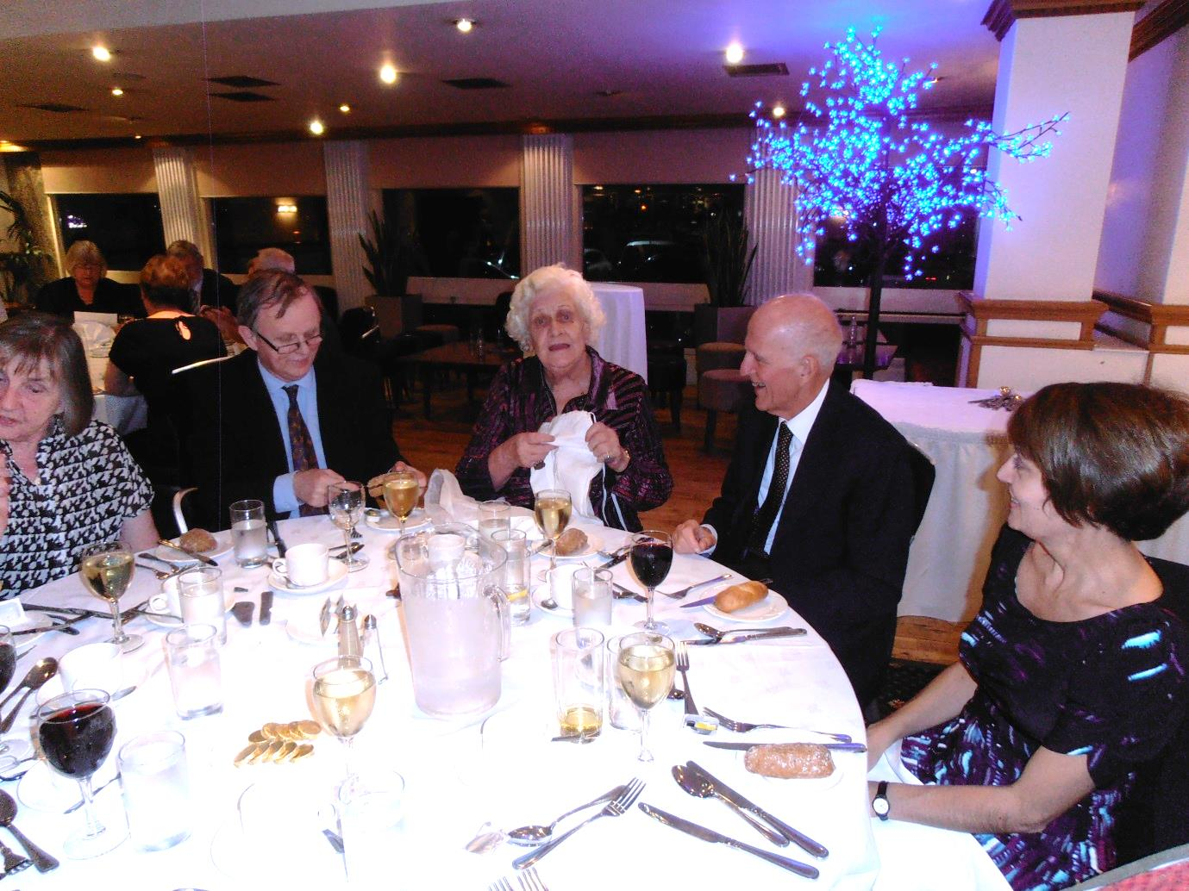
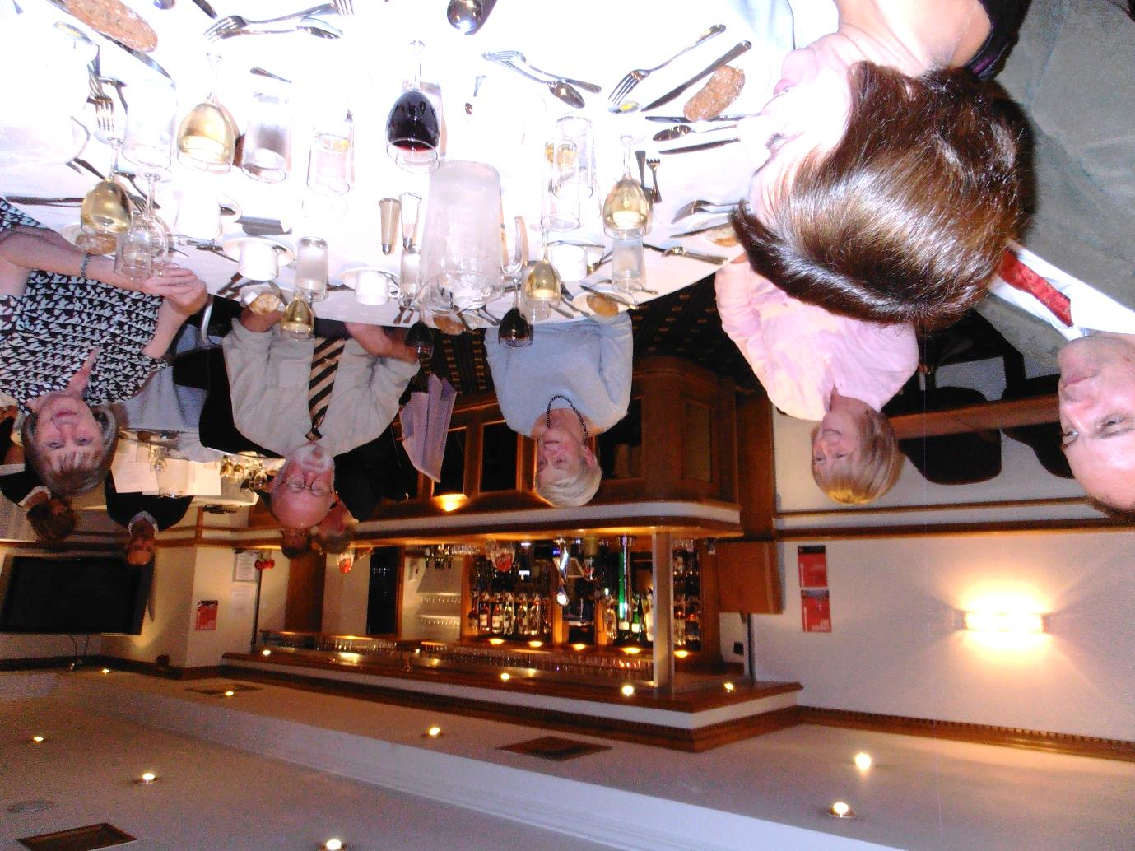
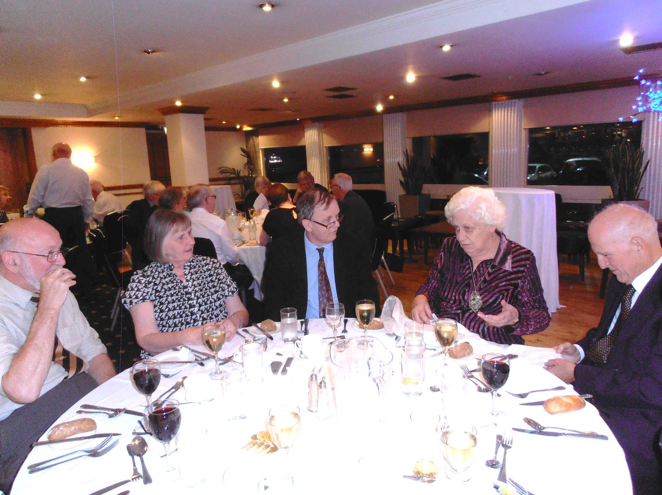
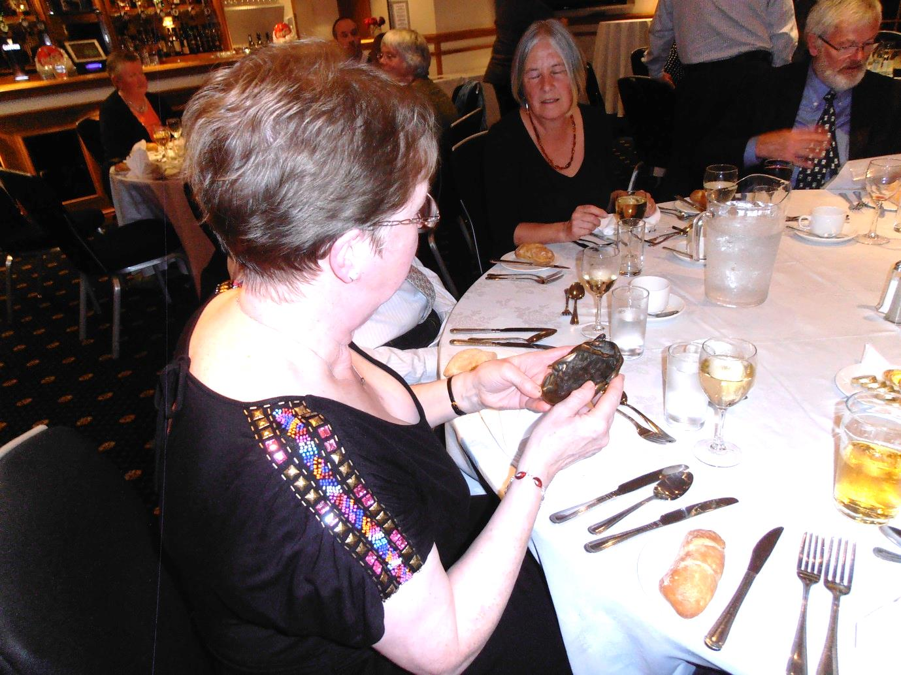
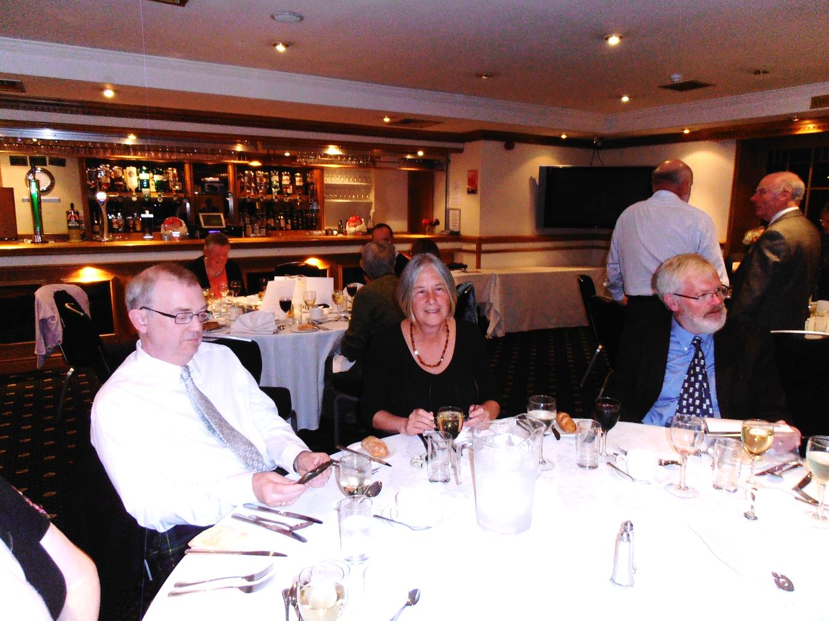
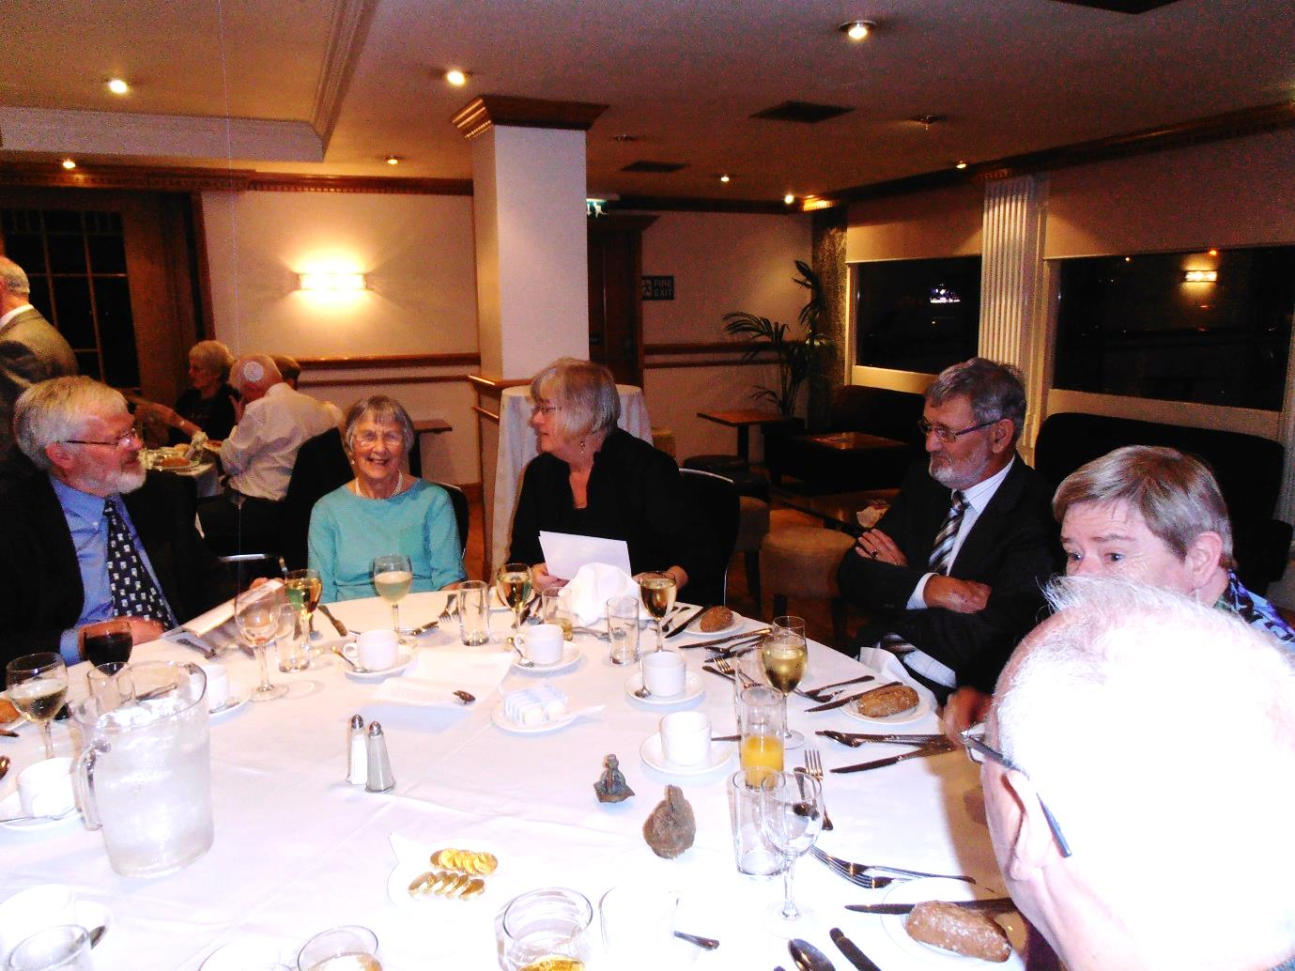
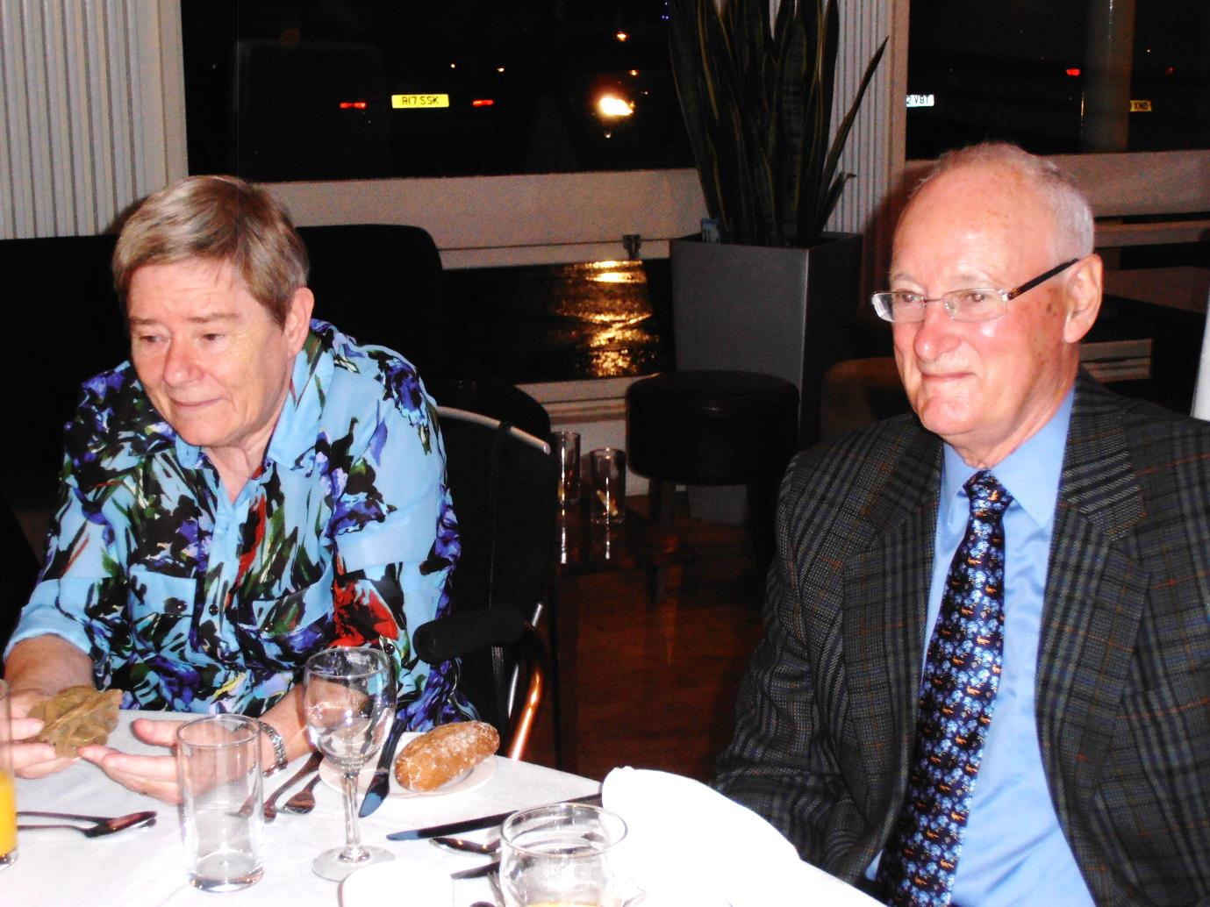
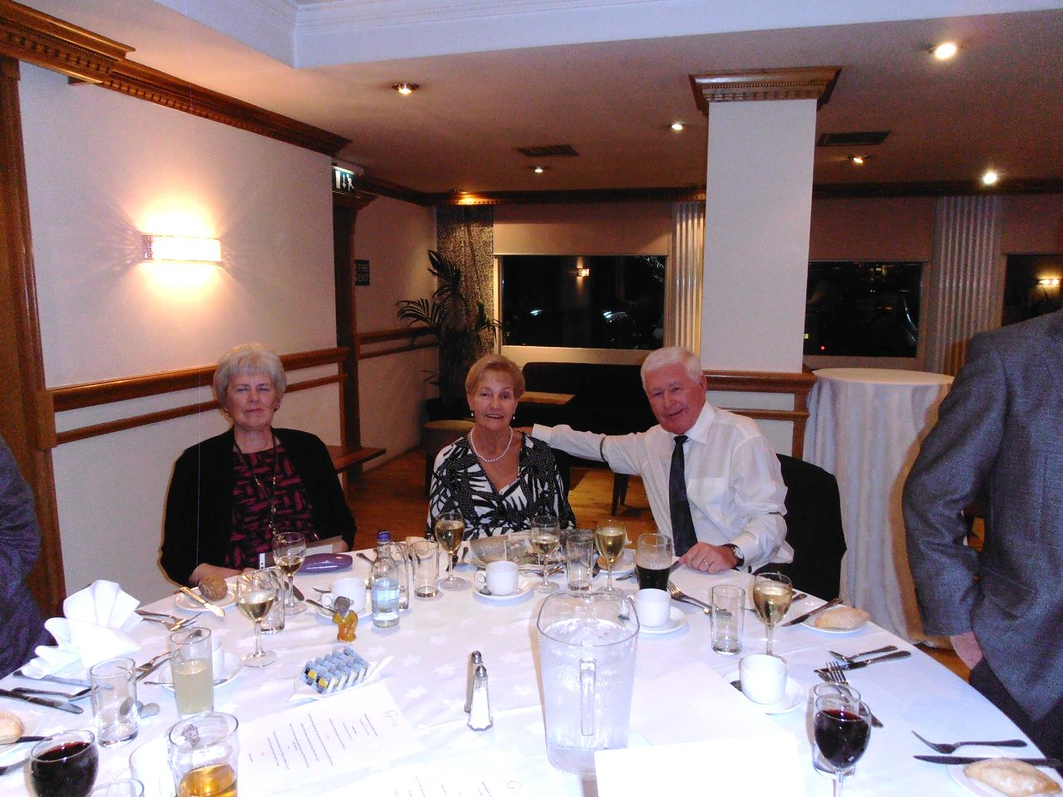
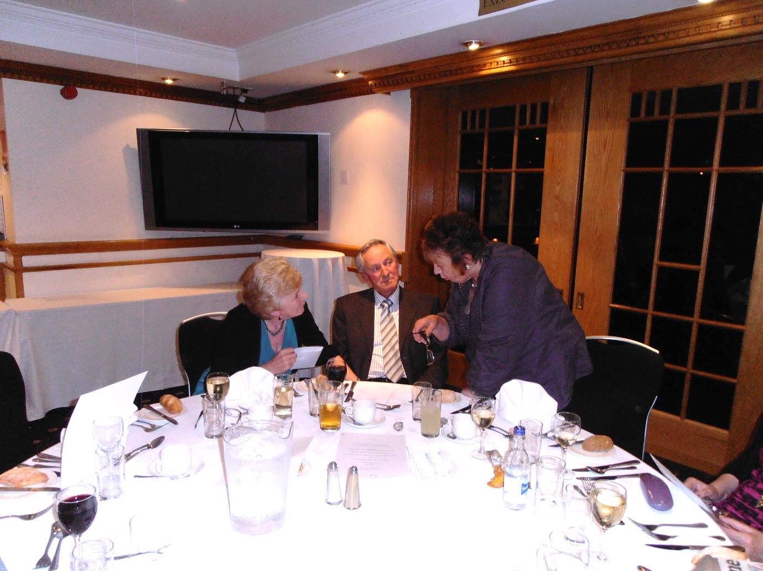
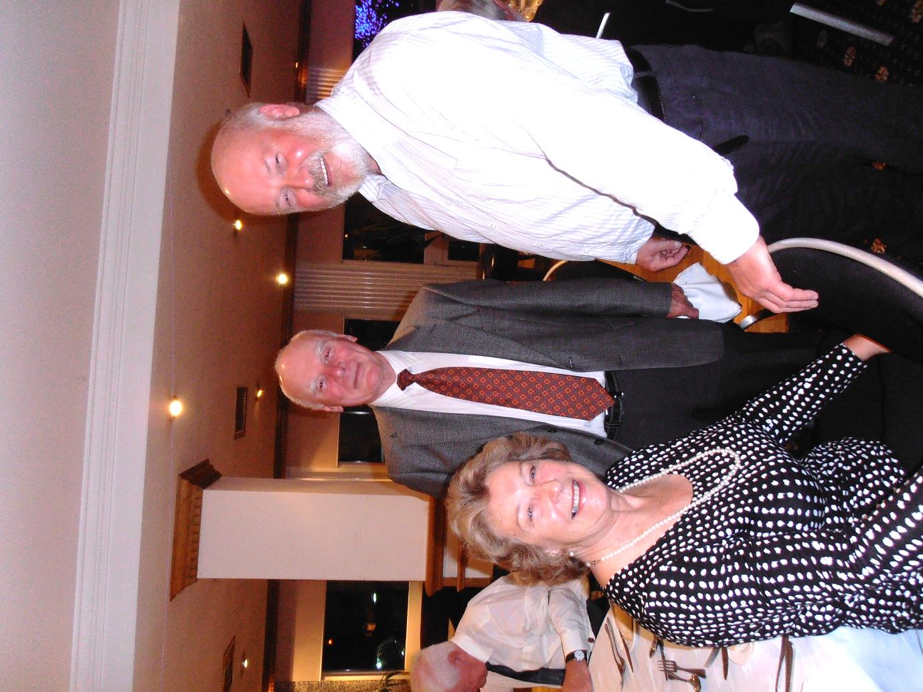

Excavation of Barrhouse Neilston, East Renfrewshire This report is dedicated to Bruce Henry, director of the excavation, who sadly died at the end of 2010 before the final report could be published.

Edited by John MacDonald
ISBN 978-0-9538730-6-7
£5.00 new publication 2013
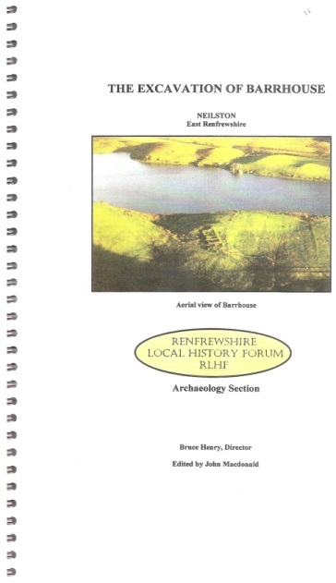
This report with drawings, maps and photographs covers in detail the phases of the excavation carried out at Barrhouse, an early farmstead above Neilston. The structure had a two compartment living areas on the east, a byre and a possible workshop on the west. Stonework on the south side indicated that the original structure was possibly a pre-improvement long house dating from the seventeenth century. Barrhouse was occupied by the Carswell family from 1738 until 1823. By the mid-nineteenth century it was abandoned and roofless. 28pp, ill 16 col, 7 b&w

